The Rule
Zvi Mowshowitz
It's a tradition that's been around since Mirage Block to search for 'The Rule,' and it got its name during Urza's Saga. The Rule is a player's best friend in an unfriendly or unbalanced draft format. When the format is young, The Rule is often as simple as any rule can be. The original version of The Rule is the one for the full Mirage Block, which goes like this:
Draft White/Blue.
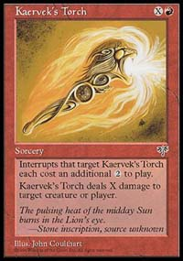
It really was that simple. The reason it was that simple was that those colors were not just the two strongest colors. They were not just two colors that worked extremely well together. They also got stronger as the draft went on. In Mirage itself, the tempting early picks were cards like red's Kaervek's Torch. To draft White/Blue a player had to start with relatively lame cards, like Griffins or Pacifism. That kept the people who didn't know The Rule out of White/Blue most of the time. Then when players opened the third pack, they got to scoop up all their Empyrial Armors and Ballista Squads. White was the primary motivation for the strategy, but blue was the perfect complement for it, especially in Visions. Thus was born The Rule. It didn't matter what a player actually opened, except for the Torch itself which was counterdrafted and/or splashed sometimes.
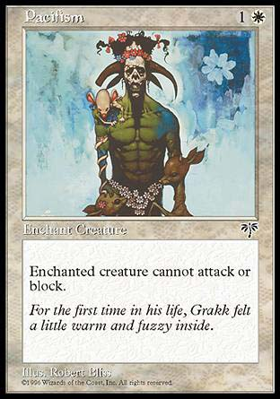
Instead, players just took the best cards for White/Blue. If the pack was weak in those colors, that only made it even easier to force those on the left out of them, even though the first pick may not have been optimal. Later on, a student of this strategy got to reap the rewards. Of course, after the people who did this started winning most of the drafts, some people caught on. But a lot of people never did. Later on, more people would recognize The Rule for other formats, as it became clearer.
This led to the first restatement of The Rule. In Tempest, red was pretty clearly the strongest color, and also had the strongest first picks. So if everyone was drafting their colors at random, The Rule would be to draft red. Instead, drafts turned into a game of chicken, because everyone else was trying to draft red too. If a player got red without fighting for it, they would usually win the draft, but more often that not, that didn't happen. The Rule was incomplete, and when it resurfaced for Urza's Saga it had a more accurate wording. The new version was:
Draft Black unless everyone else knows The Rule.
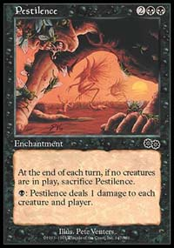
Now The Rule held no matter what. If a draft table didn't fully understand just how good black was, and it was ridiculously good, smart players drafted it if they got even half a chance. In Rochester, players were more than happy to be one of four black mages; if no two were sitting together, these were known as 'odd' or 'even' tables, to signify which positions were playing black. While it may seem like everyone knew about The Rule, there often seemed to be someone who didn't know, or who thought to himself he'd draft another color and not have to fight anyone. When trying to qualify for PTLA that year, I made top eight at three qualifiers. At the first I had to play R/G and got crushed. At the second I didn't open a power black card but went black anyway (and was rewarded) but lost to someone who did, and he went on to qualify. At the third I started with Pestilence and never looked back. Later on, other sets came out and the block became more or less balanced.
The cycle started over again for Mercadian Masques. With three packs of Mercadian Masques, the rebels were an utterly broken strategy. It wasn't a question whether or not to try and draft rebels - the only question was how big the rebel engine would get. The only reason not to draft rebels was if everyone else knew The Rule. Early on, the rebel players won table after table. I even declared online that I would only draft three colors at the Pro Tour, White, Blue and Green. The others were too weak to trouble yourself with, and letting everyone know this helped me get the cards I wanted.
The problem was that for the first time in Magic's history, everyone did in fact know The Rule. So white actually got so overdrafted it became bad, and by the time I realized the green mages were going to be the ones that did well it was too late; Mike Turian, the ultimate green mage, being on my left made me hesitate, and I was out of the running before the first draft was over.
Again, adding more sets to the format made the format better. With Nemesis and Prophecy, things changed. But I thought at the end that things were pretty unbalanced again; the colors to draft were then blue, red and green; later on, people adjusted and I started drafting all five again.
So when I knew I was going to Grand Prix: Manchester, I asked everyone one question. What is The Rule? My first answer came back: The Rule is to draft Blue/Black. This made sense, since its gold cards were excellent and the cards work well together. My second source gave me the same answer, that Blue/Black was the way to go; in fact, he was forcing it every draft like someone who truly believes he has found The Rule should. Because that's the key premise behind The Rule: Being in the right colors in a format where they are unbalanced enough is worth any one card. Therefore, your first pick in Booster Draft should always be from that color combination, since you have no information about what others are drafting, and in Rochester you should sacrifice your earliest picks to signal in those colors.
Then I did my first few drafts, and The Rule seemed to me to be: Draft White/Blue unless everyone else knows The Rule. What you were after was the classic White/Blue deck, and if you concentrated on picking up the creatures early on until you were safe, it was hard to go wrong. I did the math on which commons I wanted to play in each deck, and added in the uncommons, and it seemed to indicate that, not counting synergy, the White/Blue deck was the better choice for me. So that's what I did in Manchester, and it turned out well. At this point I'd like to look at another perspective on this format from another American that came to Manchester, Edward Fear. After starting off 8-0, he had the worst luck I've ever seen in a Rochester at the top table during the second draft, and ended up finishing 9th on tiebreakers.
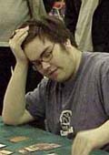
During the walk back to the hotel after the Grand Prix, Fear complained about a lack of mass removal in Invasion. He explained that in previous sets, if you played a large number of 1/1s at the same time, you were putting yourself at serious risk, with several commons available that could wipe them all out with one spell. Now, all your options are uncommon or rare, and there are not that many of them. Before, playing a lot of creatures with one toughness meant risking a Stinging Barrier, Kris Mage or other common devastating you. Now, you can win a game with three Stormscape Apprentices, as I did against Justin Gary, without worrying that it was likely I would lose the entire game to one card. He thought it was unbalancing.
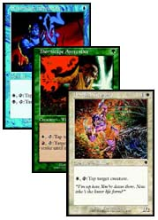
That's not strictly a good thing or a bad thing, it's just a different way of playing Limited. Like most changes in Magic, it definitely has advantages. Before, someone could draft or open an otherwise great deck, but have to worry about losing to a bad player or deck just because they played a first turn Kris Mage and he or she couldn't deal with it. In Invasion, that kind of 'oops, you lose' situation only happens because of broken uncommons and rares, such as the Masters and the Dragons. It also lets players commit all their cards to the table, which allows them to have more information to work with. As Randy Buehler put it, you would think Wandering Eye would make Finkel human but instead it only makes him even better. Putting most of the tricks onto the table (which Invasion does in other ways as well) helps here. In effect, some of the strongest commons out there are now the 'Master Decoys,' which are easier to call 'tappers:' Thornscape Apprentice, Stormscape Apprentice and Benalish Trapper. They also form the core of my favorite draft deck, White/Blue.
But there's clearly a downside to this as well. The biggest ones come from there being an amazing strategy with no real downside; there's no good reason not to use as many tappers as possible, and no reason to put them all on the table either. When it's too early to spare mana to activate them every turn, it's standard to take damage rather than trade these one casting cost 1/1s for more powerful creatures that they could kill, which is a sign of imbalance but nothing new. The first issue is how to beat someone with a lot of tappers. Often it's nearly impossible. If an opponent can tap two or even three of my creatures every turn cycle, the best case scenario is me losing control of the three strongest creatures I have. Then I still have to have enough good ones to deal with everything my opponent has. Even if that is the case, blocking becomes a virtual impossibility; after tapping three, my opponent can untap and tap three more if he or she wants to. That means I either have to get seriously ahead on life so my opponent can't afford to do things like that, which is unlikely given that the tappers come out fast, or I end up sitting back, waiting to lose. I have to hold the ground and hold the air, and sooner or later one of them will give out. In practice, that's what happens. No matter how good a deck is, an army of tappers will almost always beat it.
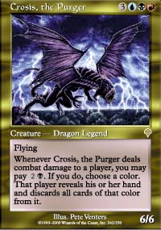
B/R/U was popular among drafters at GP-Manchester
The question that leads to is whether this in turn unbalances draft. It clearly doesn't turn out to imbalance Sealed Deck, judging from the decks that did well in Manchester. The decks that did well tended to be B/R/U more than other color combinations, for whatever reason. And the answer in draft is that the cards are definitely very strong, and are a huge advantage to W/U (and W/G) decks. But different people so far have different opinions on what The Rule is. I think it's W/U. A lot of people at Neutral Ground: New York think it's R/B. A group from the Midwest thinks it's B/U. Darwin Kastle won Grand Prix: Manchester with a three color B/R/u strategy from pack one. So far, things look balanced enough so far.
The one problem is that, as Rob Dougherty put it, 'these green decks are so bad!' Pros have traditionally hated green and beatdown in general for whatever reason, but Rob has been a definite exception, being the beatdown player on Team Your Move Games. I too took a liking to green and to aggression in Mercadian Masques block, after the early period where the Rebels were king. Why is Invasion green so poor? Because it has so much mana. It's great to be able to draft Five Color Green, and it's great to have access to Nomadic Elf, Quirion Trailblazer, Quirion Sentinel, Fertile Ground, Quirion Elf and Harrow all as commons to make that happen, but that's a huge chunk of green's playable cards being taken up by effects to produce mana. Add in the traditional number of useless cards every color gets every set, and there isn't much else to do in green. People play green in order to play other colors, and that means that if they have to draft it, they're weakening their decks. That doesn't mean green decks are always bad or that it shouldn't be drafted. It just means that for Five Color Green to be good, it has to be allowed to pick up its mana basically for free. If players are using early picks to get Harrow, the deck won't turn out well even if you get all the mana in the world. On the other hand, if I get that Harrow 11th then I can draft even better cards than usual, plus I get mileage out of otherwise bad cards like Ordered Migration. Invasion doesn't have anything that's imbalanced enough to indicate a new version of The Rule for everyone yet. But players in the Top 8 of a Qualifier, should be prepared to let their first few picks go to cards they don't want that much in order to get the colors they want. Combined with individual styles of play and drafting experience, there's bound to be a strategy that's worth the sacrifice.

